Quantum Electron Localization as a Complementary Mechanism for Disruption in PINCH and TOKAMAK Plasmas
Christos D. Papageorgiou, PhD Imperial College
Ass. Prof at National Technical University of Athens
chrpapag@gmail.com

Abstract
Disruption phenomena in pinch-based and tokamak plasma systems remain one of the major obstacles to achieving stable nuclear fusion. Existing interpretations based on magnetohydrodynamic (MHD) instabilities successfully describe large-scale plasma behavior but do not fully account for the experimentally observed rapid onset, spatial localization, and neutron emission characteristics associated with disruption events.
In the present work, a complementary theoretical framework based on transient electron localization is proposed. By modeling the system as a bounded electron gas governed by the Schroedinger equation, it is shown that the fundamental eigenmode naturally produces a maximum electron density at the center of the system. Under strong transient excitation, this behavior may correspond to effective charge localization in high-density electron systems.
The proposed mechanism is further supported by experimental observations of disruptions in thin conducting wires subjected to high-current pulses, where rupture consistently occurs near the midpoint under conditions not fully explained by thermal effects alone. Extending this analogy to plasma columns, it is suggested that similar localization effects may contribute to disruption dynamics and influence neutron emission through non-equilibrium interaction mechanisms.
The proposed framework is not intended to replace MHD theory but rather to complement it by introducing transient sub-scale electron dynamics that may contribute to disruption formation.

Keywords: PINCH plasma, TOKAMAK, disruption, electron localization, plasma instability, neutron generation

1. Introduction
Controlled nuclear fusion remains one of the most complex and ambitious goals of modern physics, with significant technological and theoretical challenges still unresolved despite decades of intensive research. In particular, plasma confinement devices such as pinch systems and tokamaks have demonstrated remarkable progress, yet their operation is still fundamentally limited by the occurrence of disruption phenomena.
These events, characterized by the sudden loss of plasma stability, rapid redistribution of energy, and often accompanied by intense bursts of neutron emission, represent a major obstacle to achieving sustained fusion conditions. While conventional interpretations based on magnetohydrodynamic (MHD) theory have successfully described large-scale plasma instabilities, they do not fully account for the rapid temporal evolution and spatial localization observed experimentally. These discrepancies suggest that additional physical mechanisms, possibly operating at smaller spatial and temporal scales, may play a significant role in the initiation and development of disruptions.

2. Limitations of MHD Models
Magnetohydrodynamics has long been the dominant theoretical framework for describing plasma behavior in fusion devices, providing a macroscopic description that treats plasma as a conducting fluid under the influence of electromagnetic fields [1-4]. Within this framework, instabilities such as sausage and kink modes have been extensively studied and are widely accepted as key contributors to plasma disruption.
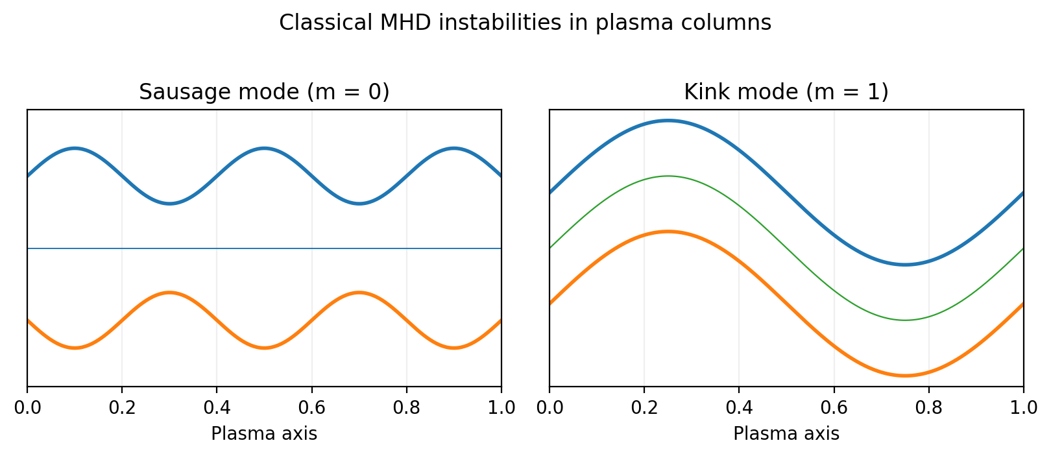
Figure 1. Classical sausage and kink instabilities in plasma columns.
However, MHD inherently relies on assumptions of quasi-neutrality, continuous charge distribution, and averaged particle behavior, which limit its ability to capture fast transient phenomena and localized charge dynamics [5]. In particular, the theory does not adequately describe situations in which significant charge separation or electron density gradients arise over very short timescales. Furthermore, experimental observations of neutron bursts and rapid energy release suggest the presence of non-equilibrium processes that cannot be fully explained within the MHD paradigm. These limitations indicate that while MHD remains essential for understanding global plasma behavior, it may be insufficient to explain all aspects of disruption phenomena.

3. Experimental Evidence from Conducting Wires
A key motivation for the present work arises from experimental observations in thin conducting wires subjected to strong pulsed currents. In such experiments, it has been repeatedly observed that the wire does not fail randomly along its length but instead tends to rupture near its midpoint, even under conditions where thermal effects alone cannot account for the observed behavior.
This phenomenon has been documented across a wide range of experimental setups and suggests the presence of a localized internal mechanism responsible for the concentration of forces [7]. The dependence of the effect on the temporal characteristics of the applied current pulse further indicates that dynamic charge redistribution plays a crucial role. These observations cannot be satisfactorily explained by classical electromagnetic theory alone, particularly when interpreted within a purely thermal or resistive framework. Instead, they point toward the existence of transient charge concentration effects, which may give rise to strong localized electrostatic forces capable of inducing mechanical disruption.

4. Quantum Model of Electron Localization
To provide a theoretical basis for these observations, the conducting system can be modeled as a bounded electron gas described by the Schroedinger equation. The conductor is approximated as a one-dimensional bounded electron gas with geometric boundary conditions. For a conducting segment of length L, the fundamental eigenfunction may be written as
Y(x) = A sin(pi x / L)
|Y(x)|^2 = A^2 sin^2(pi x / L)
This distribution exhibits a maximum at the center of the system, indicating a natural tendency for electron concentration. Under this approach, the spatial distribution of electrons is governed by the eigenfunctions of the system, which are determined by the boundary conditions imposed on the structure. For a one-dimensional conducting segment, the fundamental eigenfunction leads to an electron density distribution proportional to the square of a sinusoidal function, which naturally exhibits a maximum at the center of the system.
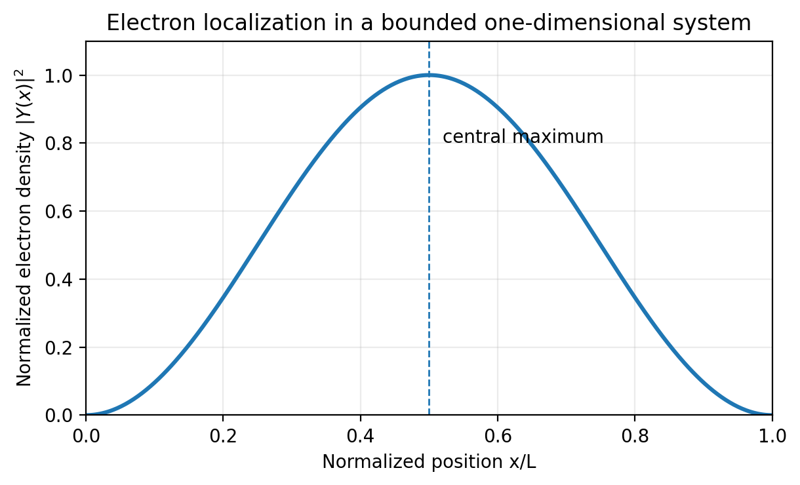
Figure 2. Electron probability density in a bounded system showing a central maximum.
While in classical interpretations this distribution is treated as a probability density, in systems with a very large number of free electrons it may correspond to transient effective charge localization in high-density electron systems. Under transient excitation conditions, such as those produced by strong current pulses, the system may temporarily occupy low-order eigenstates, leading to a measurable concentration of electron density at specific spatial locations. This provides a plausible mechanism for the observed midpoint localization in wire disruption experiments.

5. Physical Interpretation of Electron Concentration
The transient concentration of electrons at the center of a conducting structure has important physical implications, particularly in terms of force generation and energy redistribution. As electrons accumulate in a localized region, strong electrostatic repulsion forces develop due to the mutual interaction between charges. These forces can act in directions that are not aligned with the current flow, giving rise to shear or longitudinal stresses within the material. In sufficiently strong excitation regimes, these stresses may exceed the mechanical strength of the structure, leading to rupture or fragmentation.
Importantly, this mechanism does not require the introduction of non-standard electromagnetic forces and remains consistent with classical electrodynamics when combined with a quantum description of charge distribution. The resulting picture is one in which disruption is not solely the result of macroscopic instabilities but may also be driven by microscopic charge dynamics that become significant under transient conditions.

6. Extension to Plasma Systems
The extension of this mechanism from solid conductors to plasma systems requires careful consideration of the differences between the two environments. In plasma, the presence of both electrons and ions, along with the quasi-neutrality condition, complicates the direct application of solid-state models. However, under strong electromagnetic excitation, such as that occurring in pinch discharges or tokamak disruptions, the plasma may experience transient deviations from equilibrium, including localized charge imbalances. Furthermore, magnetic confinement can act as an effective boundary condition, restricting particle motion and potentially enabling the formation of standing-wave-like structures in the electron distribution.
Under these circumstances, it is plausible that similar localization effects may arise, leading to regions of enhanced electron density within the plasma column. These regions could, in turn, generate strong electrostatic fields and contribute to the onset of disruption.

7. Implications for Disruption Phenomena
If transient electron localization occurs in plasma systems, it may provide a complementary explanation for several key features of disruption phenomena that are not fully captured by existing models. In particular, the rapid onset of disruptions, often occurring on timescales shorter than those predicted by MHD instabilities, may be explained by the fast dynamics of electron redistribution. Additionally, the spatial localization of disruption events, including the formation of narrow filaments or localized collapse regions, is consistent with the presence of concentrated charge zones.
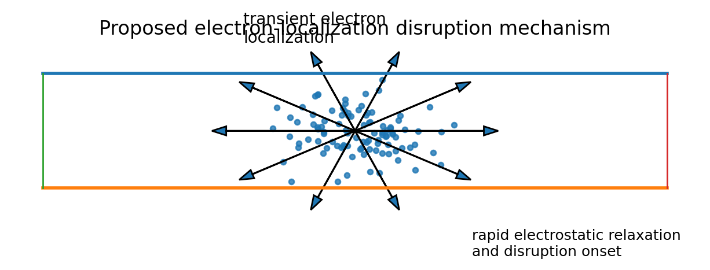
Figure 3. Conceptual diagram of electron concentration at a plasma center leading to rapid electrostatic relaxation and disruption onset.
The release of energy during disruption may also be influenced by the sudden relaxation of electrostatic forces, leading to explosive-like behavior. These considerations suggest that disruption may be a multi-scale phenomenon, involving both macroscopic instabilities and microscopic charge dynamics.

7.1 Fan-Type Instability and Filament Divergence
A fan-type instability may also be considered as a possible geometric expression of longitudinal or internal force-driven filament divergence. In such a picture, plasma filaments do not only undergo radial contraction or bending, as in standard sausage and kink modes, but may also diverge outward from a central region of instability. This representation is useful for comparing classical MHD descriptions with models in which transient internal charge concentration and subsequent force relaxation contribute to the disruption process.
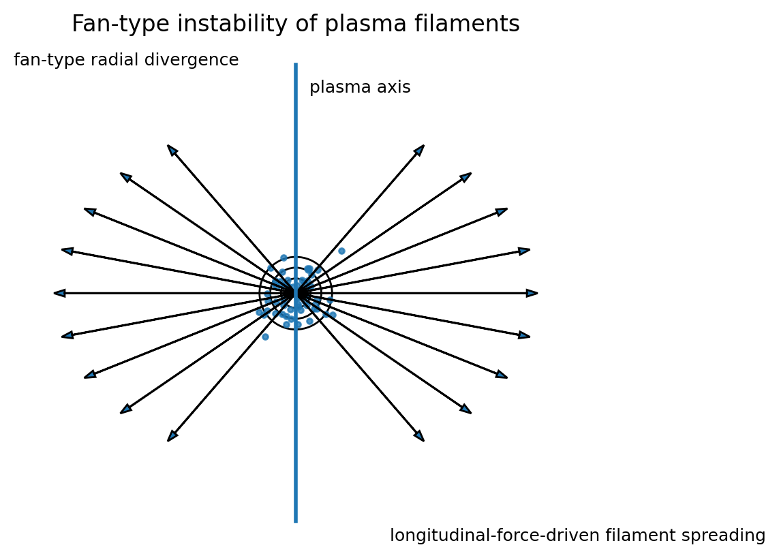
Figure 4. Fan-type instability of plasma filaments showing radial divergence from a localized central region.

8. Neutron Generation and Non-Thermal Effects
One of the most intriguing aspects of disruption phenomena in pinch experiments is the observation of neutron emission under conditions that do not always correspond to classical thermonuclear fusion. Experimental studies, including those reported in Neutron Production in Linear Deuterium Pinches, have shown that neutron bursts often occur in close temporal association with instability events [6].
This raises the possibility that non-thermal mechanisms may contribute to neutron production. Within the framework proposed in this work, the transient concentration of electrons could create conditions in which high local electric fields and non-equilibrium interactions facilitate non-equilibrium interaction mechanisms. While such mechanisms remain speculative and require further investigation, their consideration may help explain discrepancies between observed neutron yields and those predicted by purely thermal models.

9. Testable Predictions
The theoretical framework proposed in this work leads to several testable predictions that can be examined experimentally. First, it predicts the existence of transient peaks in electron density prior to the onset of disruption, which could potentially be detected using advanced diagnostic techniques such as Thomson scattering or fast imaging methods. Second, it suggests a correlation between the temporal structure of the applied current pulse and the likelihood of disruption, implying that carefully shaped pulses may influence stability.
Third, the model predicts that neutron emission, when present, should exhibit spatial localization correlated with regions of high electron density. The verification or refutation of these predictions would provide valuable insight into the validity of the proposed mechanism.

10. Conclusion
In this work, a complementary theoretical framework has been proposed for the interpretation of disruption phenomena in pinch and tokamak plasma systems. By introducing the concept of transient electron localization, derived from a quantum description of bounded electron systems, a new perspective is offered that may help explain experimental observations not fully accounted for by existing models.
The approach does not aim to replace magnetohydrodynamic theory but rather to extend it by incorporating additional physical mechanisms operating at smaller scales. While the proposed ideas require further validation through both experimental and numerical studies, they provide a coherent and physically grounded basis for future investigation. Ultimately, a deeper understanding of disruption phenomena may contribute to the development of more stable and efficient fusion devices.

References
[1] Hender, T.C. et al., MHD Stability and Disruptions, Nuclear Fusion, 2007.
[2] Helander, P., Sigmar, D.J., Collisional Transport in Magnetized Plasmas.
[3] Wesson, J., Tokamaks, Oxford University Press.
[4] Kadomtsev, B.B., Tokamak Plasma: A Complex Physical System.
[5] Connor, J.W., Hastie, R.J., Runaway Electrons in Tokamaks.
[6] Anderson, O.A. et al., Neutron Production in Linear Deuterium Pinches, Phys. Rev., 1958.
[7] Papageorgiou, C.D., Raptis, T.E., Ionic Collisions in Metallic Lattices, EPJ Applied Physics, 2011.

